Add JavaScript Functions for repeated tasks in PDF Document.

To do this, create a .JS file in the AppData Folder.
The folder can be found here %AppData%\Kofax\PDF\PowerPDF\JavaScript. You can call the file anything, Leave the global.js file untouched.
Here, I have added a function called Prepare and included the JavaScript commands in the function. You can have multiple functions in a file, and you can also have multiple files. There is no limitation on the number of files, however a single file should not exceed 4MB in size.
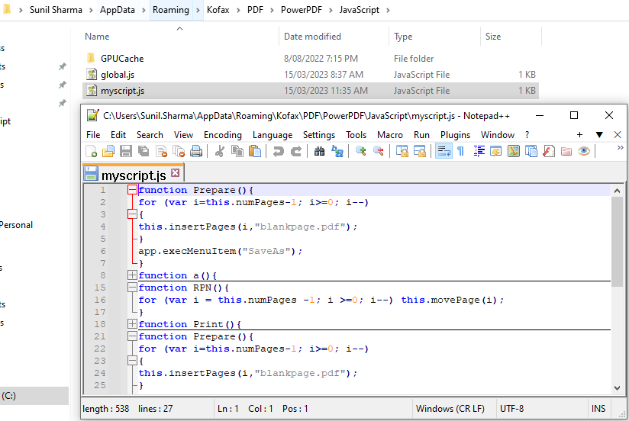

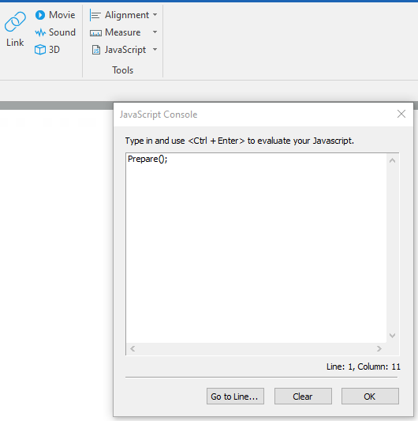
Usage:
To use this function on any open PDF file in PPDF,
Go to the JavaScript Console tool under Edit JavaScript JavaScript Console.
Call your function making note that this is Case Sensitive, as shown to the right.
Prepare();
And press Control + Enter to execute the command.

Here are the Functions demonstrated in the Video,

Function Prepare
function Prepare(){
for (var i=this.numPages-1; i>=0; i--)
{
this.insertPages(i,"blankpage.pdf");
}
app.execMenuItem("SaveAs");

Function to Reverse Pages

function RPN(){
for (var i = this.numPages -1; i >=0; i--) this.movePage(i);
}

