Create a database link to the CSV file:

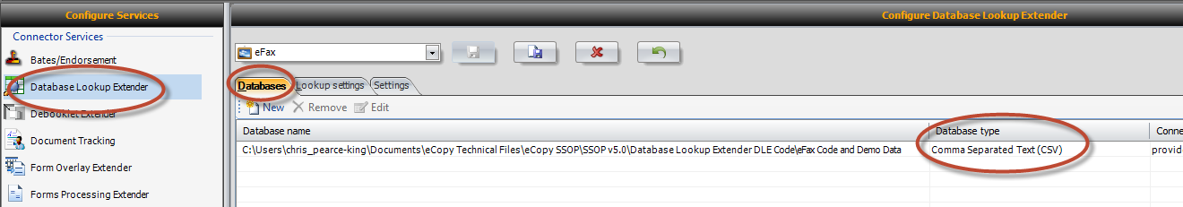

Create the following entries:

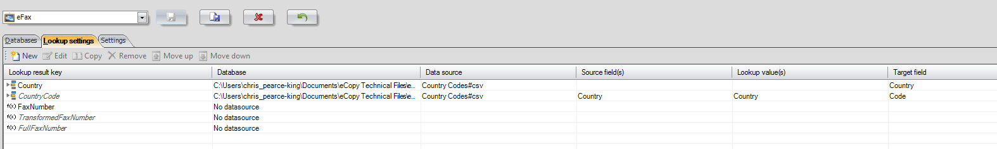

Country is a simple lookup which will display all the entries in the Country column:

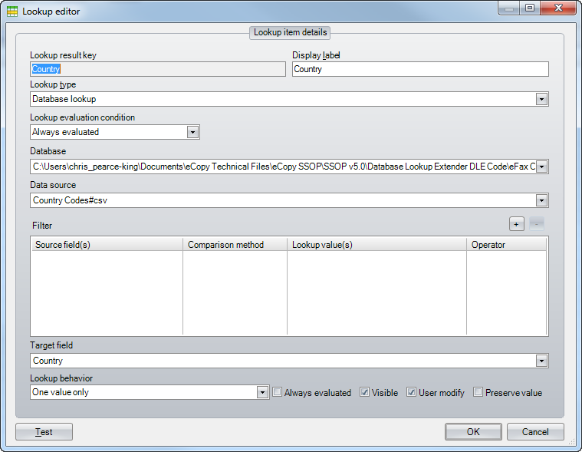

Country Code is a lookup:

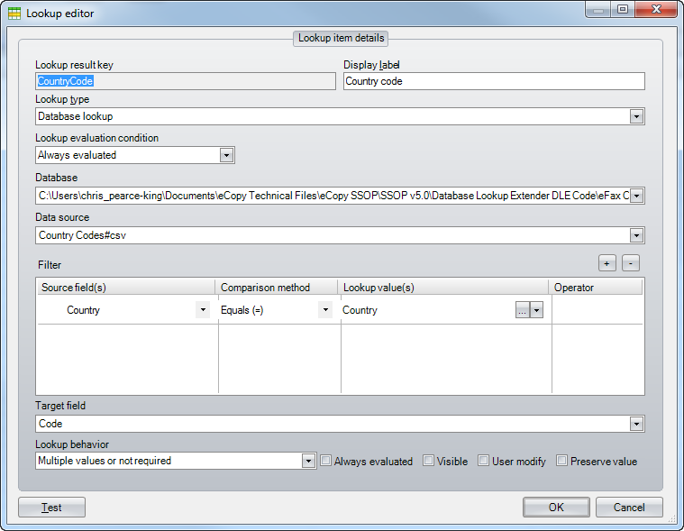

Fax Number is a user entry field:

@""

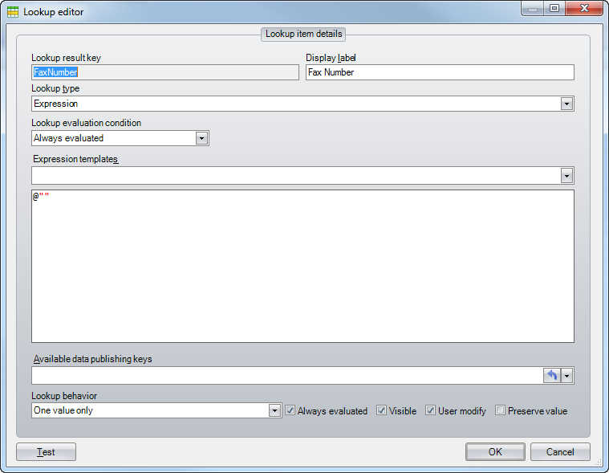

TransformedFaxNumber is an Expression:

@"***«Database Lookup Extender.default.FaxNumber»***".TrimStart('0').Replace(" ", "")

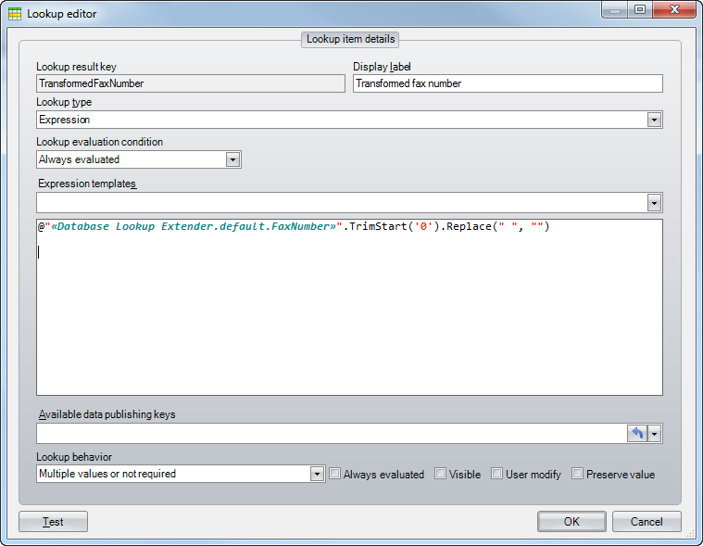

FullFaxNumber is also an Expression:

@"***«Database Lookup Extender.eFax.CountryCode»***" + ***«Database Lookup Extender.eFax.TransformedFaxNumber»***

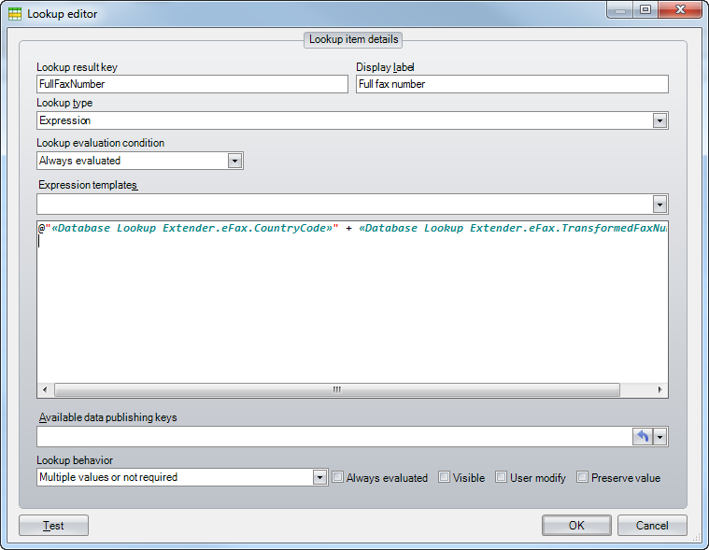

Connector Configuration:

Remember to select “Default recipients and Data publishing:

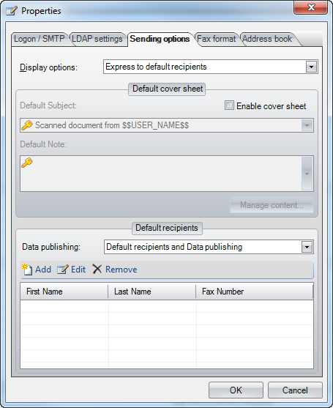

And also to map the fields:

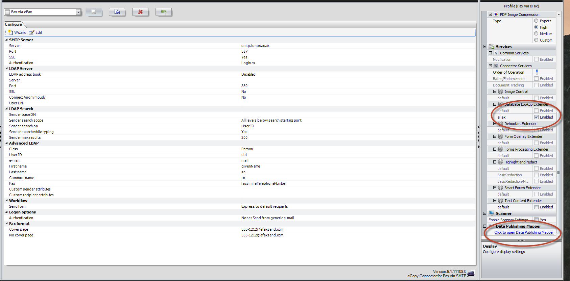

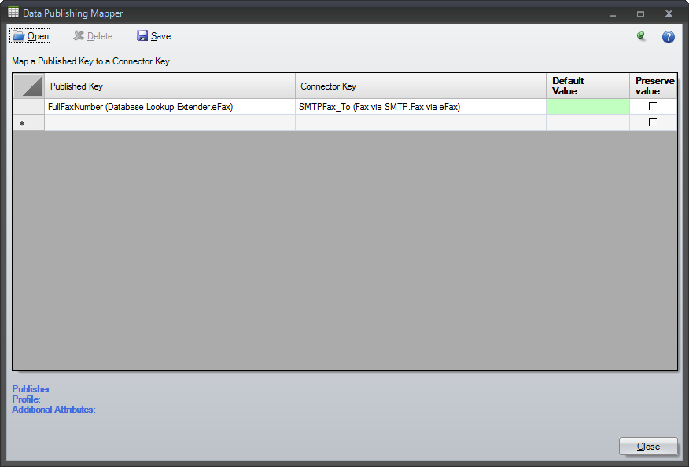

Lastly, build out the correctly formatted fax number for your service:

